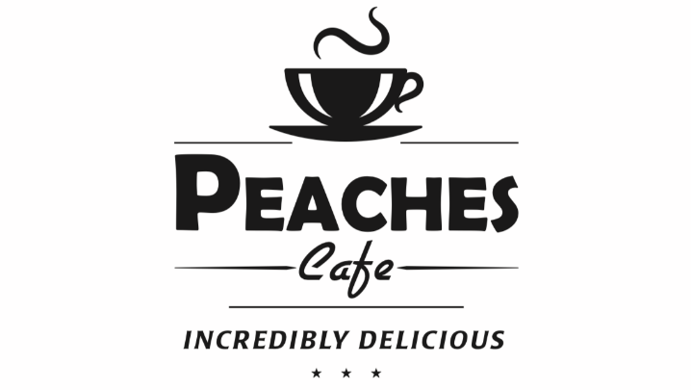
Guilderland Restaurant Week
Enjoy a three-course meal by choosing one item from each category for the price of $20.20.
Appetizer
Cup of Soup Du Jour
Classic Caesar Salad
Cranberry Walnut Salad
A Bed of Salad Greens with Dried Cranberry, Walnuts, Tomato & Cucumber. Served with Raspberry Vinaigrette Dressing.
Entrée
Mac & Cheese with Chicken & Bacon
A Rich Multi Cheese Sauce with Grilled Chicken & Applewood Smoked Bacon mixed into Penne Pasta.
Pasta Chicken Bruschetta
Sautéed Chicken Breast in a Fresh Tomato, Basil, Garlic & Olive Oil Sauce. Finished with a Balsamic Glaze over Penne Pasta.
Eggplant Parmigiana
Layers of Breaded Eggplant, Marinara Sauce & Melted Mozzarella Cheese. Served with a side of Pasta.
Crab Cakes
Tender Crab Cakes topped with Roasted Pepper Cream Sauce. Served with Rice & Vegetable.
Chicken Piccata
Tender Chicken Breast with a Lemon Caper Wine Sauce. Served with Rice & Vegetable.
Maple Soy Salmon
Tender & Flaky Salmon Filet prepared in a Sweet & Tangy Glaze. Served with Rice & Vegetable.
Dessert
Hot Fudge Sundae
Vanilla Ice Cream, Creamy Hot Fudge, Whipped Cream, Nuts & a Cherry.
Apple, Peach or Pumpkin Pie a la Mode

